

American International University-Bangladesh (AIUB)  
**Department of Computer Science  
Faculty of Science & Technology (FST)**

**Project Title:   
Integrated Application Usage Tracking & Parental Control System**

**Supervised by:**

TONNY SHEKHA KAR

A Software Engineering Project Submitted

By

|  |  |  |  |  |
| --- | --- | --- | --- | --- |
| **Semester: Summer_23_24** | | **Section: H** | **Group Number: 09** | |
| SN | Student Name | Student ID | Contribution (CO3+CO4) | Individual Marks |
| 1 | A. F. M. RAFIUL HASSAN | 22-47048-1 |  |  |
| 2 | MD. ASHIKUZZAMAN ABIR | 22-47006-1 |  |  |
|  |  |  |  |  |
|  |  |  |  |  |
|  |  |  |  |  |

**Work Breakdown Structure**

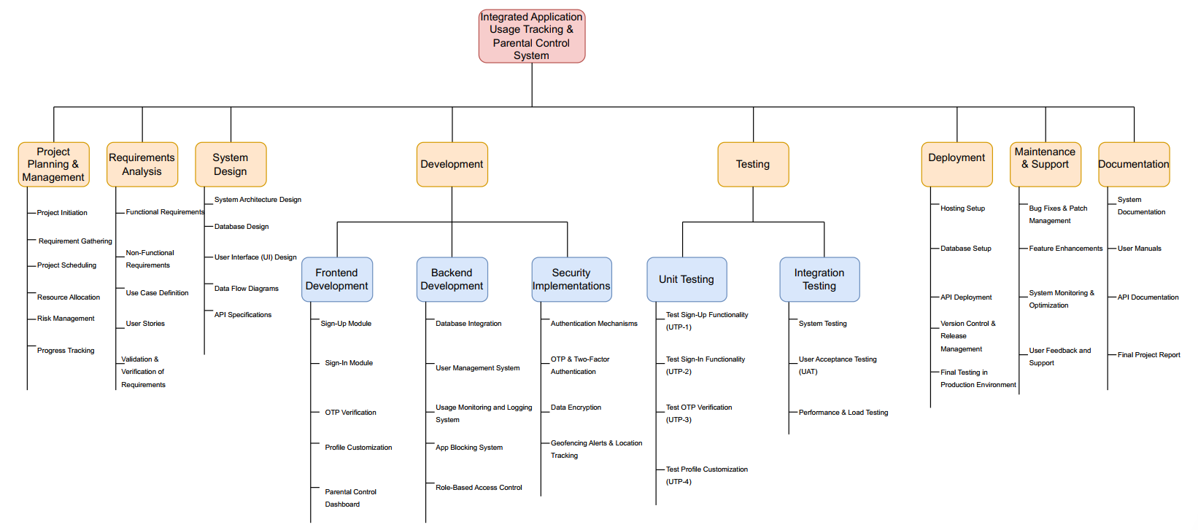

**Timeline Chart-1**

**Organic Model:**

PM=2.4*(5000/1000)^1.05=13

DM=2.5*(13)^.38=6.63(6*4=24 weeks)

ST=13/6.63=1.96 = 2 person

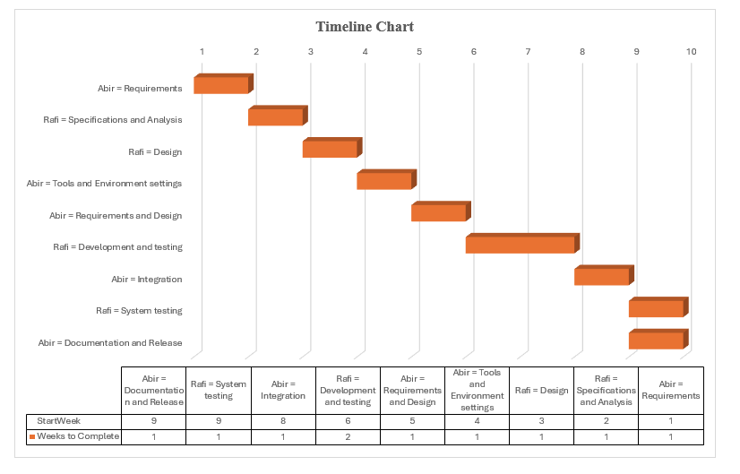

**Timeline Chart-2**